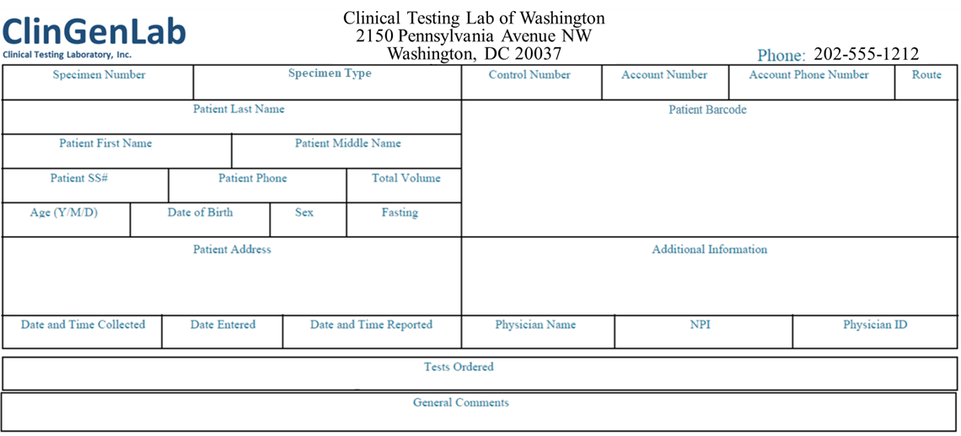 

**Clinical test results for Insulin Panel**

| **TEST** | **RESULT** | **REFERENCE INTERVAL** |
| --- | --- | --- |
| Hgb A1c w eAG Estimation  Hemoglobin A1C  Please Note:  Pre-diabetes: 5.7 – 6.4  Diabetes: >6.4  Estim. Avg Glu (eAG) | 7.6%  169 mg/dL | 4.8 – 5.6  <117 mg/dL |
| Serum Glucose | 132 mg/dL | <100 mg/dL |
| Serum anti-Insulin antibody | .73 mIU | 2 - 20 mIU |
| Anti-GAD65 | pos |  |
| Anti-IA2 | pos |  |
| Anti-ZNT8 | neg |  |